LAB

REPORT

# IRE 212 : IoT Architecture and Technologies Sessional

|  |  |
| --- | --- |
| PREPARED BY  Mehrin Farzana  ID: 2101013  Session: 2021-2022  Date: 30/11/2024 | SUPERVISED BY  Suman Saha  Assistant Professor & Chairman  Department of IRE, BDU |

|  |  |
| --- | --- |
| logo1 | BANGABANDHU SHEIKH MUJIBUR RAHMAN DIGITAL UNIVERSITY  (BDU) |
|  |  |

**List of Experiments**

* 1. IoT-Based Motion Detection System using ESP32 and PIR Sensor

**Experiment No.:** **01**

**Experiment Statement: IoT-Based Motion Detection System using ESP32 and PIR Sensor**

**Theory**:

The Internet of Things (IoT) integrates physical devices, sensors, and software to enable seamless data exchange and monitoring. A motion detection system is a practical IoT application used in home security. The PIR (Passive Infrared) sensor detects infrared radiation emitted by moving objects, triggering alerts when motion is detected. Using the ESP32 microcontroller, the detected motion is transmitted over Wi-Fi to the Blynk IoT platform for real-time monitoring.

This system allows for theft alerts and enhances home security by notifying the user about unauthorized movements through push notifications.

**Components**:

* ESP32 Microcontroller
* PIR Motion Sensor
* Wi-Fi Network
* Blynk IoT App
* Connecting Wires

**Circuit:**

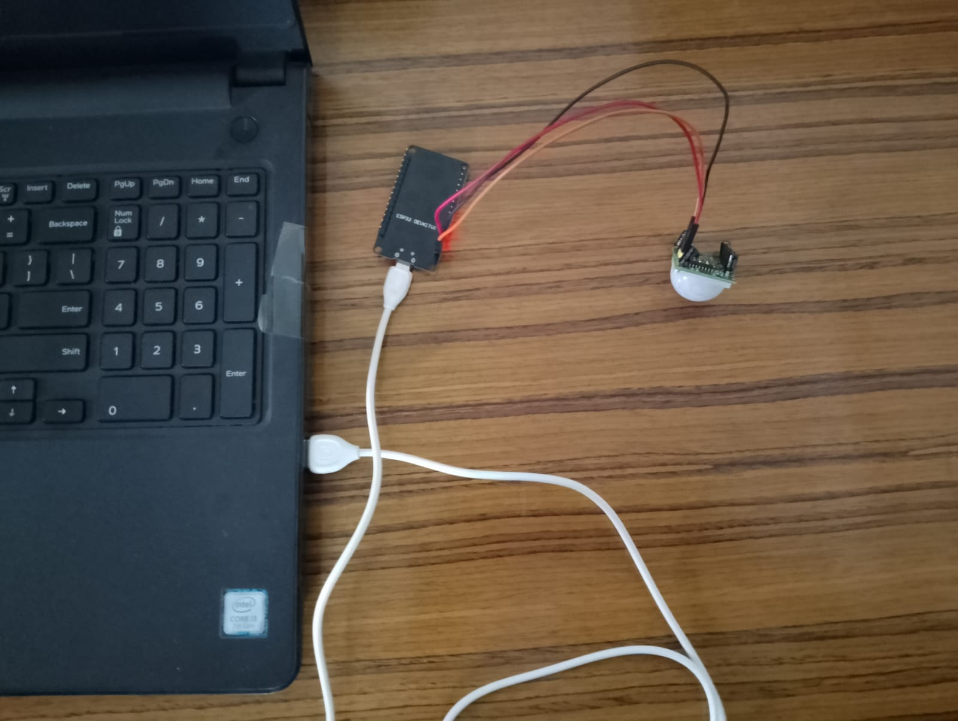

Fig 1: Circuit diagram of IoT based Motion system

**Code:**

#define BLYNK_TEMPLATE_ID "TMPL6Zu-0oBiD"

#define BLYNK_TEMPLATE_NAME "iot motion detection"

#define BLYNK_AUTH_TOKEN "wnAoDCRF4wGjJXwnLEXVdqrIO2hf7CwX"

#define BLYNK_PRINT Serial

#include <WiFi.h>

#include <BlynkSimpleEsp32.h>

char auth[] = BLYNK_AUTH_TOKEN;

char ssid[] = "Rupu's dimension";

char pass[] = "zaqwsxcde";

#define PIR_SENSOR  13

BlynkTimer timer;

void notifyOnTheft() {

  int isTheftAlert = digitalRead(PIR_SENSOR);

  Serial.println("PIR Sensor Value: " + String(isTheftAlert));

  if (isTheftAlert == 1) {

    Serial.println("Theft Alert in Home");

    Blynk.logEvent("theft_alert", "Theft Alert in Home");

  }

}

void setup() {

  pinMode(PIR_SENSOR, INPUT);

  Serial.begin(115200);

  Serial.println("Connecting to Wi-Fi...");

  Blynk.begin(auth, ssid, pass);

  if (WiFi.status() == WL_CONNECTED) {

    Serial.println("Wi-Fi Connected.");

    Blynk.logEvent("test_event", "Blynk Test Event");

  } else {

    Serial.println("Wi-Fi Connection Failed.");

  }

  timer.setInterval(5000L, notifyOnTheft);

}

void loop() {

  Blynk.run();

  timer.run();

}

**Explanation of Code:**

* **Libraries**: Essential libraries for Wi-Fi and Blynk functionalities are included.
* **Wi-Fi Credentials**: The SSID and password are specified for Wi-Fi connection.
* **PIR Sensor**: The sensor is connected to GPIO 13 of the ESP32 and initialized as an input.
* **Blynk Initialization**: The ESP32 connects to the Blynk cloud using the provided authentication token.
* **Motion Detection**:
* The notifyOnTheft() function checks the PIR sensor's state every 5 seconds.
* If motion is detected, it triggers a theft alert notification using the Blynk app's log event functionality.
* **Main Loop**: The Blynk.run() and timer.run() functions ensure continuous operation of Blynk services and periodic execution of the theft detection logic.

**Output:**

* When motion is detected, the Blynk app sends a **"Theft Alert in Home"** notification.
* Serial Monitor displays:
  + Current PIR sensor value (0 or 1).
  + "Theft Alert in Home" when motion is detected.
* The system continuously monitors and updates every 5 seconds.

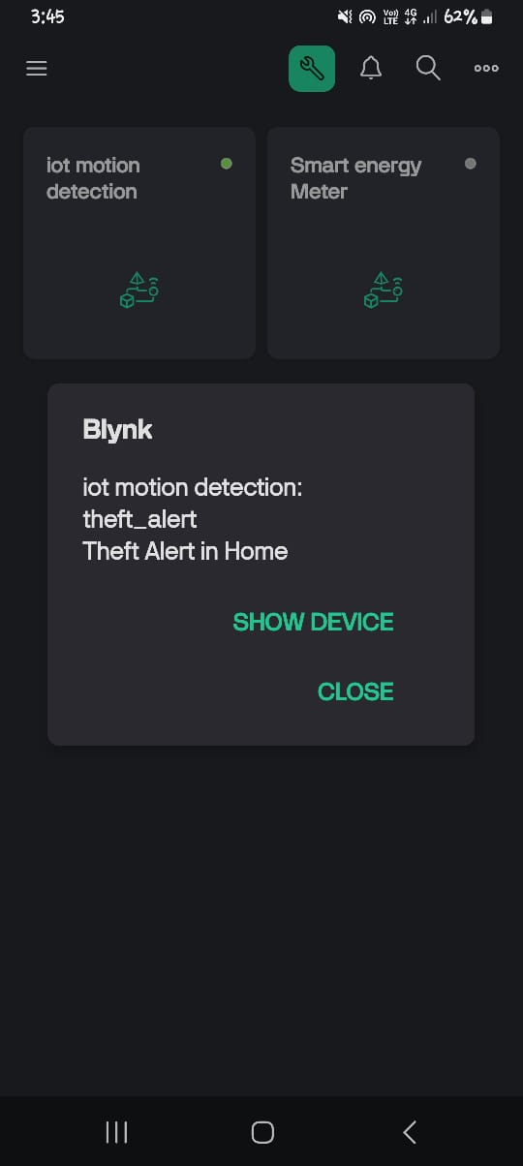

Fig 02: Message on Blynk App After Motion detection

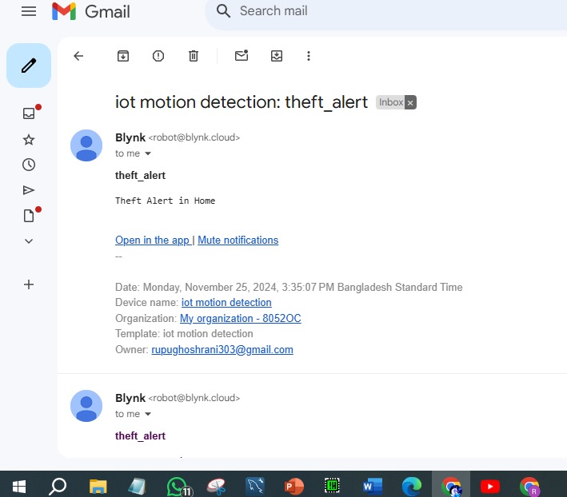

Fig 03: Email after motion detection

**Conclusion:**

This experiment demonstrates the implementation of an IoT-based motion detection system using an ESP32 microcontroller and PIR motion sensor. The integration of the Blynk IoT platform enables real-time notifications, enhancing home security. This scalable and efficient system can be further developed for industrial or commercial applications.